**DAILY ONLINE ACTIVITIES SUMMARY**

|  |  |  |  |  |  |  |  |
| --- | --- | --- | --- | --- | --- | --- | --- |
| **Date:** | **20/05/2020** | | | | **Name:** | **Sinchana K N** | |
| **Sem & Sec** | **4th semester ,Bsec** | | | | **USN:** | **4AL18CS083** | |
| **Online Test Summary** | | | | | | | |
| **Subject** | | |  | | --- | | **OBJECT ORIENTED CONCEPTS (18cs45)** | | | | | | |
| **Max. Marks** | | **30** | | **Score** | | **19** | |
| **Certification Course Summary** | | | | | | | |
| **Course** | **PYTHON FOR MACHINE LEARNING** | | | | | | |
| **Certificate Provider** | | | **GREATLEARNING**  **ACADEMY** | **Duration** | | | **5 HOURS** |
| **Coding Challenges** | | | | | | | |
| **Problem Statement: 3 programs** | | | | | | | |
| **Status: EXECUTED** | | | | | | | |
| **Uploaded the report in Github** | | | | **yes** | | | |
| **If yes Repository name** | | | | **Lockdown_coding 1** | | | |
| **Uploaded the report in slack** | | | | **yes** | | | |

Online Test Details:

Today OBJECT ORIENTED CONCEPTS was conducted of first module. Total marks for the test was 30. The online test conducted includes MCQ kind questions and also output prediction.

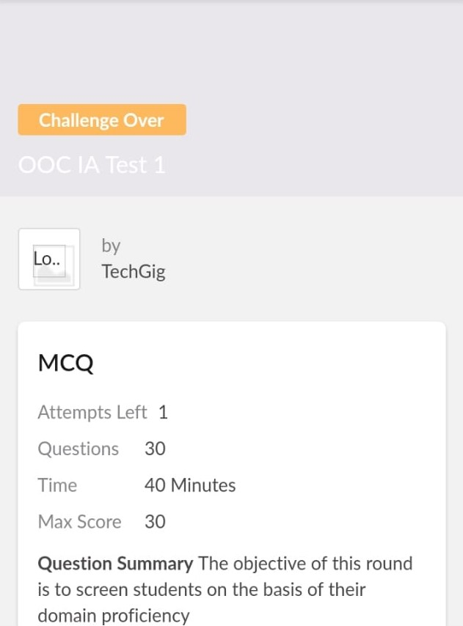

**Coding Challenges:**

Today I solved 4 coding challenge,

1.Related to linked list:

Test Case 1:

If a linked list is: 1 → 2 → 3 → 4 → 5 → 6 → 7 → 8

The value of size k is 2

Then the linked list looks like: 2 → 1 → 4 → 3 → 6 → 5 → 8 → 7

Test Case 2:

If a linked list is: 1 → 2 → 3 → 4 → 5 → 6 → 7 → 8

The value of size k is 3

Then the linked list looks like: 3 → 2 → 1 → 6 → 5 → 4 → 8 → 7

2. program print Duplicates which prints the duplicate elements of the given array:

Given an array a[] of size n which contains elements from 0 to n-1, write a program print Duplicates which prints the duplicate elements of the given array. If no duplicate element is found print -1.

Input:

The first line of input must contain an integer n which denotes number of elements of Array. Second line contains n space separated integers denoting elements of array a[].

Output:

Print the duplicate elements from the given array.

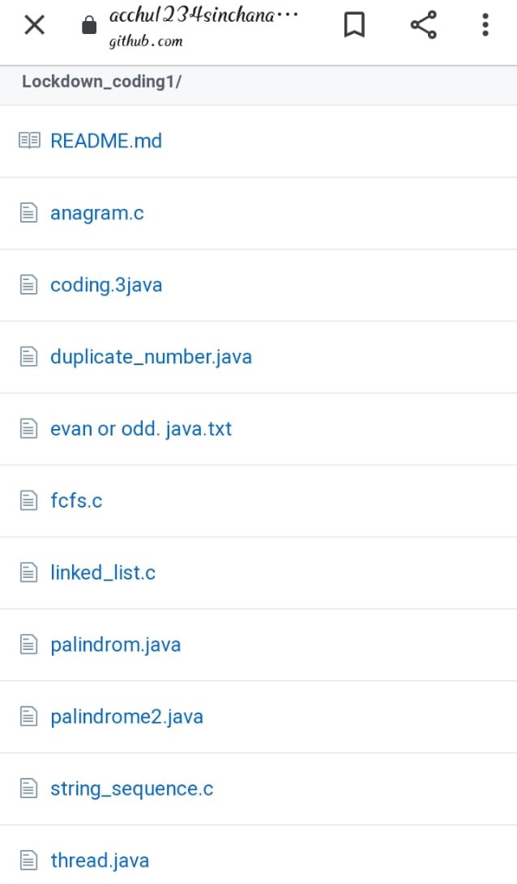

**Certification Course Summary:**

**I have taken my online certification course in great learning academy. The course which I have taken is python for machine learning. Course contain vedios,tutorials, assessment. Today I have gone through the conditional statements video and I came to know that python is easy to learn we can also use python when our data analysis task needs to be incorporated into a production database.it is a great tool to implement algorithms for production use.**

